**Quiz Manager**

**User Guide**

**Author**

**Subaandh Sambharathan VELLAKINAR KRISHNAKUMAR**

**Overview:**

The Quiz Manger application is developed using JAVA it runs both as a console-based application and on a GUI. The Database used is PostgreSQL. Javafx is used for GUI. The users are the admin and the student the admin can perform operations like Create/Read/Update/Delete on all available tables in the database. The student can login to attend Quiz based on the topic and difficulty selected. The Javadoc generated. There are more than 60 questions of different types like MCQ, open.

**Prerequisites/Requirements:**

• Eclipse IDE (Download link - <https://www.eclipse.org/downloads/>)

• PostgreSQL **Version 12.5**

(Download link - <https://www.enterprisedb.com/downloads/postgres-postgresql-downloads>)

• Install javafx (eclipse marketplace) and postgres

**Note:**

There are two users.

1. The student (default username**: subaandh** password**: 123**) . New students can be added when logged in as a admin
2. The admin (**username: admin password: admin**).

There are two runnable files

1. Launcher.java
2. InitializeGUI.java

**Application setup and User guide:**

**Overview:**

Step 1: Setting up the program

Step 2: Adding Libraries

Step 3: Running the program

Step 4: How to use and output

**Step 1: Setting up the program**

**Setting up the database**

Open pgadmin and create new database first.

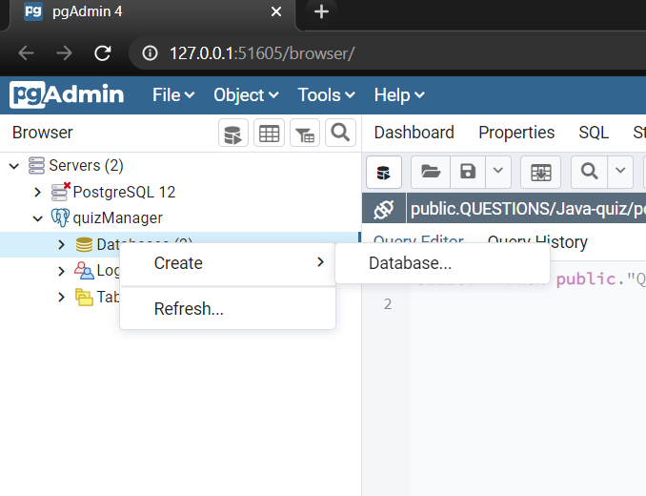

Righ click on the newly created database and click restore and add the Database_Quizmanager.sql file.

**Using git: In eclipse**

File->Import->under Git->Projects from Git->Clone URI

Goto github and copy the clone link - <https://github.com/Subaandh-VK/Java-Final_Project.git>

**Or**

Download it as zip and import as a project

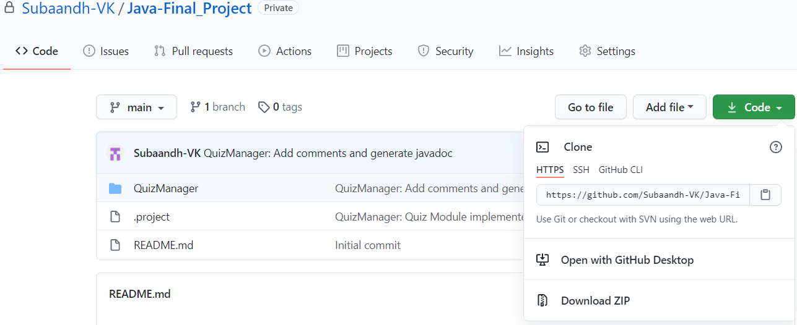

Add it in the URI and click next. In this below screen enter directory. And Click Next

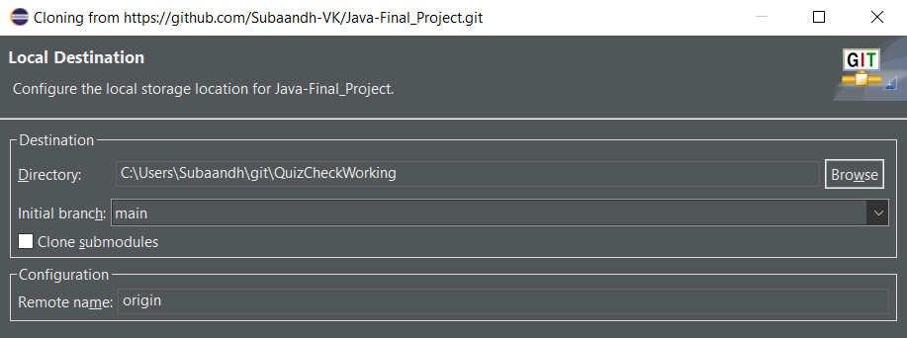

After cloning it will look like this

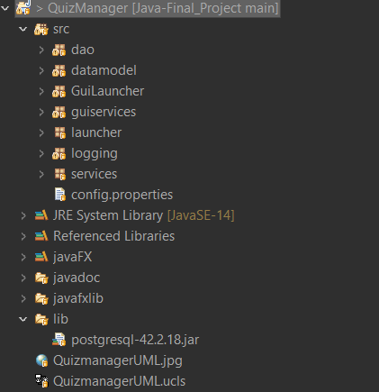

Goto config.properties file and configure the postgresql path, postgresql username, and password. See image below.

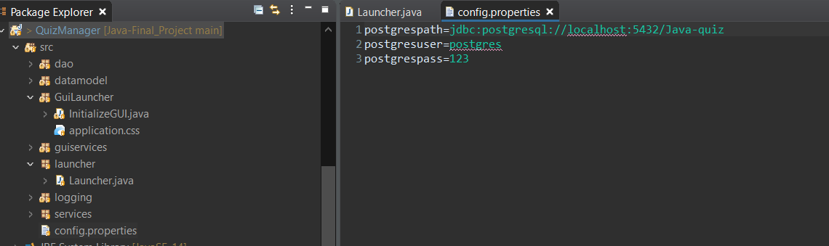

**Step 2: Adding Libraries**

1. Select and Right click on the Project QuizManager. **Click Properties.**
2. Goto JavaBuildPath->Add Jar. Navigate to lib folder in Quizmanager project and click postgresql.jar and apply and close.

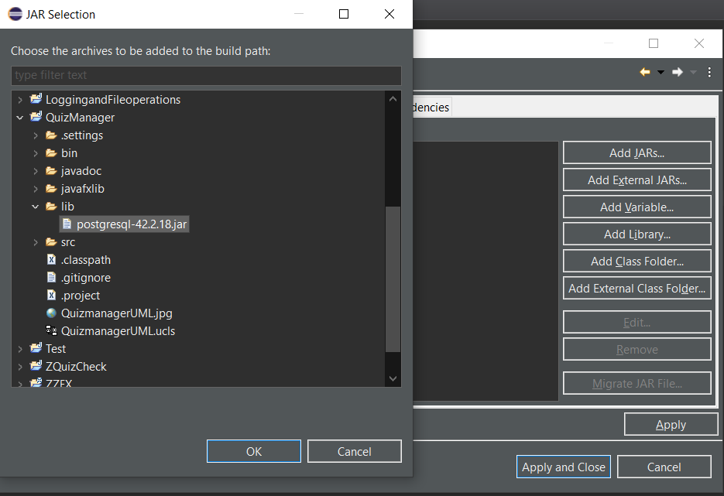

1. If the JavaFX is installed properly it should work fine.

If not add the library manually like this.

Select and Right click on the Project QuizManager. **Click Properties->JavaBuildpath->Add jar**

**QuizManager->src->javafxlib->javafxsdk-11.0.2->lib and select all JAR’s and add it. Apply and close.**

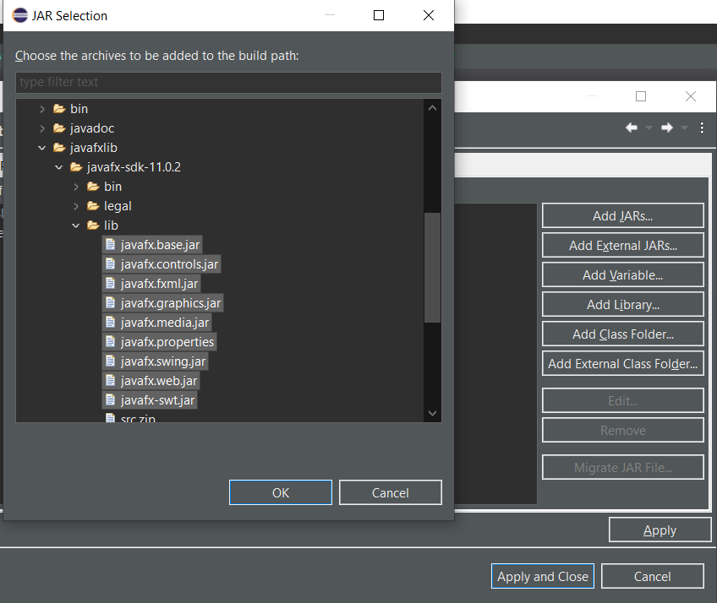

**Step 3: Running the program**

**Running it on console:**

src->launcher->Launcher.java and click Run.

**Running with GUI:**

src->GuiLauncher->InitializeGUI and Click Run

**After this if you face any runtime errors when running InitializeGUI do the following.**

Goto : javafxlib->javafx-sdk-11.0.2->lib and Right Click Properties

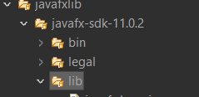

This screen will appear **copy the location link.**

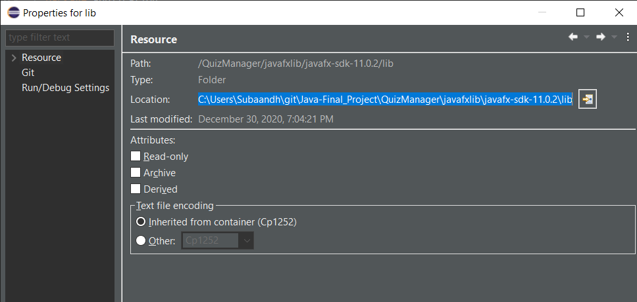

Click dropdown near run and select run configurations

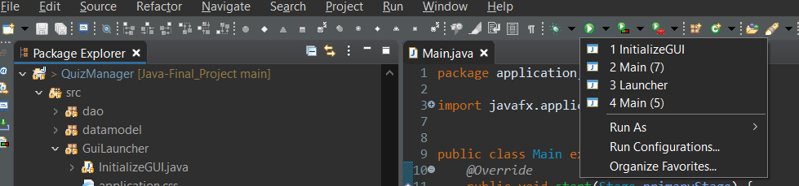

In Run configuration goto Arguments tab->VM arguments

**In VM arguments paste this command:** --module-path "**path to lib directory**" --add-modules javafx.controls,javafx.fxml

Replace the path to lib with the link that you copied from the properties of lib folder.

**Example:**

--module-path "C:\Users\Subaandh\git\Java-Final_Project\QuizManager\javafxlib\javafx-sdk-11.0.2\lib" --add-modules javafx.controls,javafx.fxml

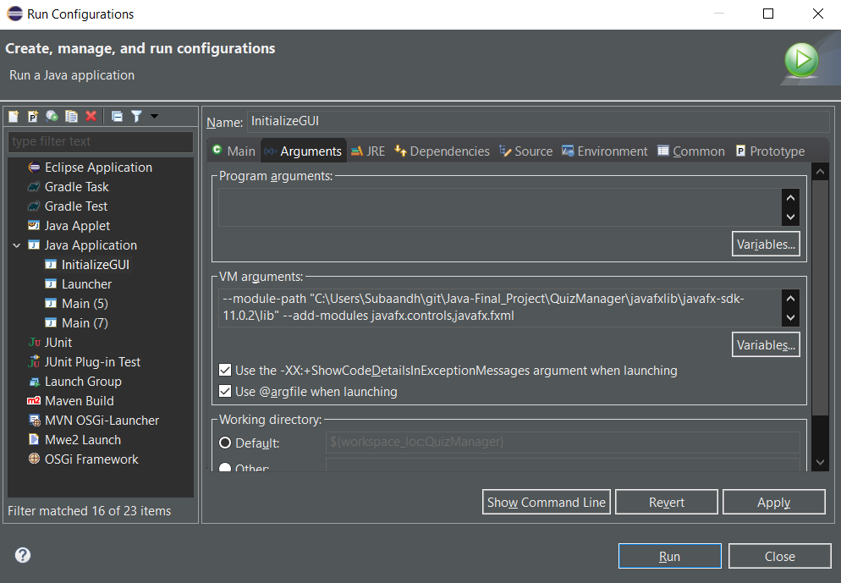

Click Run.

**Step 4: How to use and Output**

**On Console: Run Launcher.java**

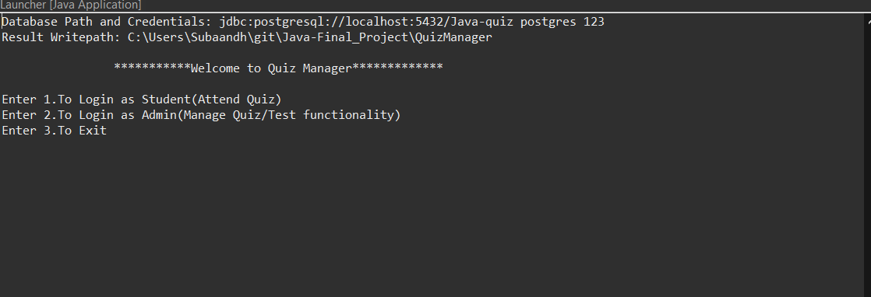

To login as student enter 1

To login as admin enter 2

To exit enter 3

Once check the postgreSQL details before proceeding.

Enter username and password

(**username: subaandh password: 123**)

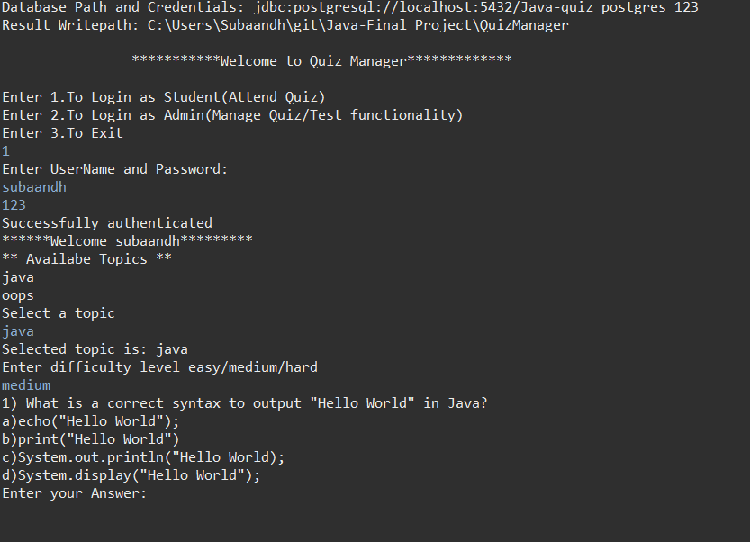

After authentication is successful the student selects topic and difficulty

The quiz starts

Give the answers fully and don’t use any short forms as it won’t be evaluated.

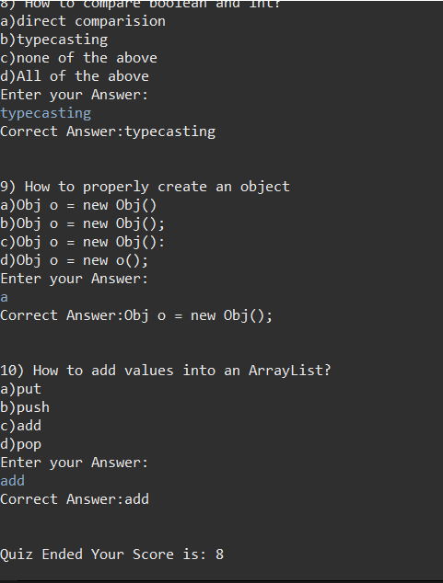

Once the Quiz ends the score will be displayed.

**Admin operations example:( username: admin, password: admin )**

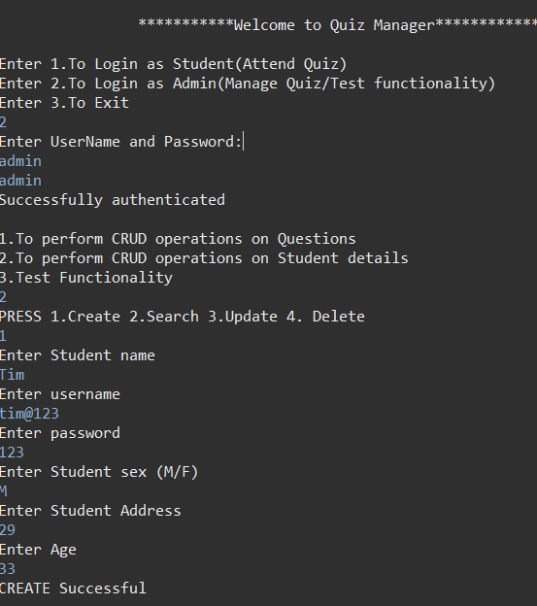

**With GUI JavaFx:**

only quiz can be attended.

src->GuiLauncher->InitializeGUI and Click Run.

If any errors occurs, check step 3

Student login screen will appear enter the username and password. (**username: subaandh password: 123**) Click login

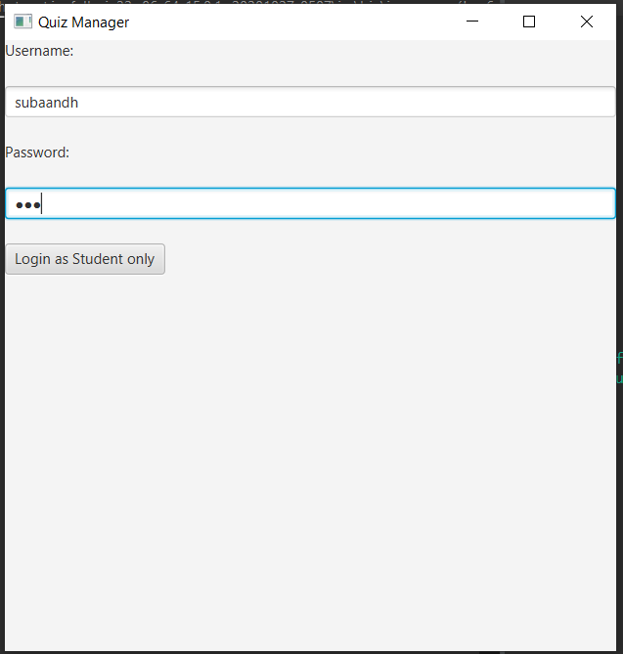

In the next page select the topic: Confirm

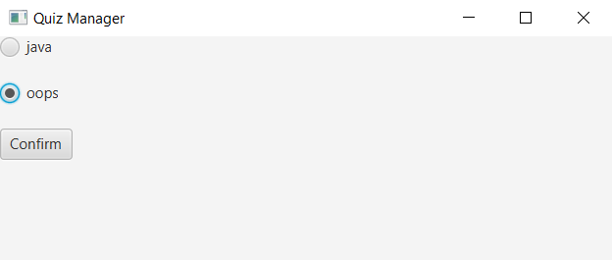

Next select difficulty: Confirm

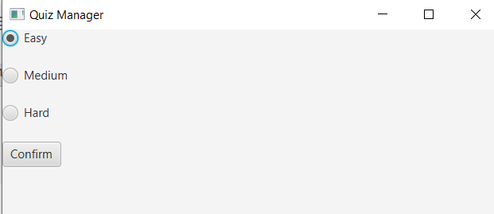

The Quiz starts:

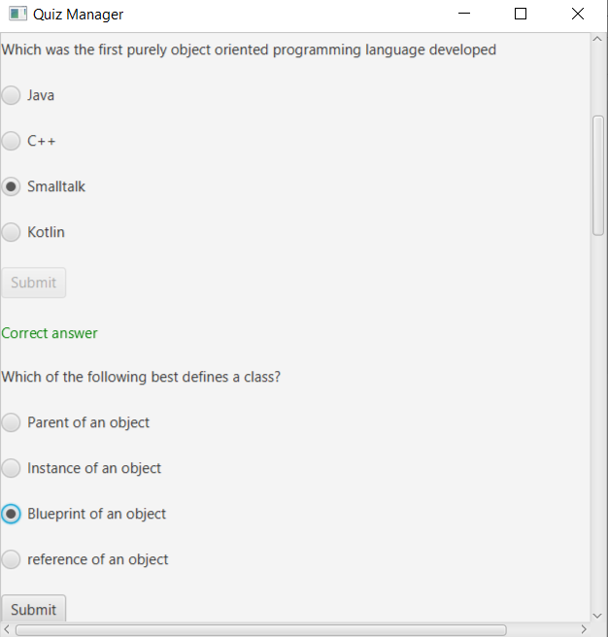

After answering each question select submit to validate it.

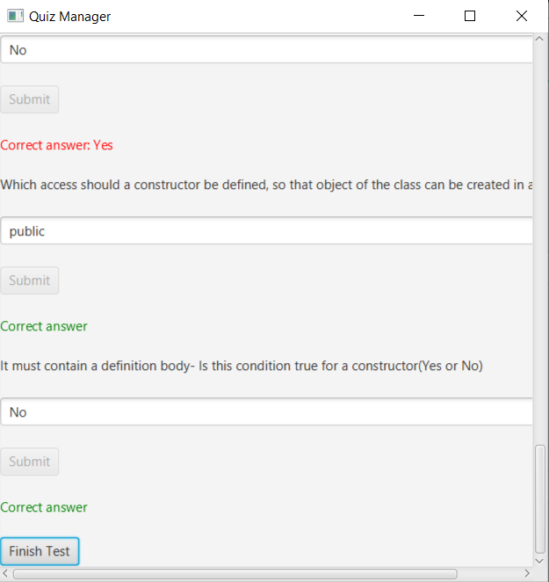

After answering all question click Finish Test

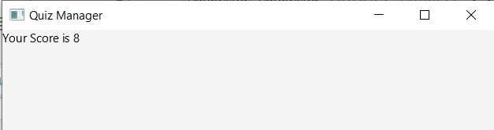

The score will be displayed.